Planet of the Apes Timeline

1871

Charles Darwin publishes On the Origin of Species, which details his controversial theory of evolution.

1880

Sebastian Thorne, a man deemed mentally unstable in his own time, is made the unwilling test subject for a time machine created by a scientist named Foucault. With Thorne strapped into the machine, Foucault throws the switch and Thorne disappears, never to be seen again. (Adventure Comics, Urchak’s Folly)

1915

Albert Einstein published his General Theory of Relativity. Ten years later he adds the Special Theory of Relativity.

1939-1945

The Second World War. The war ends with the dropping of atomic bombs on Japan.

1950-1953

Korean War. During the war, a young corporal named Walter O’Reilly displays an unusual “Sixth sense,” earning him the nickname Radar. It is later believed that his ability is the result of radiation from atomic testing.

1961

President Kennedy makes his bold declaration to have the United States place a man on the Moon by the end of the decade. At the same time, he secretly orders the creation of ANSA, a military branch of NASA, to explore deep-space propulsion systems, particularly FTL drives.

1962

Cuban Missile Crisis. As a response to the crisis, the United States and Great Britain begin work on a secret space station, the Oberon, which is built on the far side of the Moon. It will later be relocated to Saturn.

1964

A group of children display dangerous telepathic abilities before they are eventually destroyed by a bomb.

1969

Neil Armstrong walks on the Moon.

1971

A teenager displays an unusual ability to control rats, which he uses to extract revenge on his tormenters. (Willard)

1972, Spring.

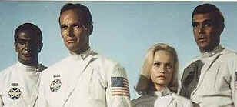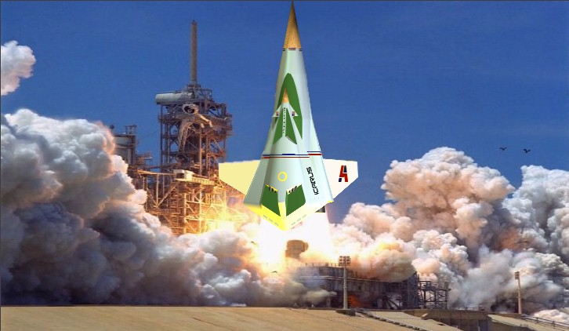

Colonel Taylor and his crew board their spacecraft for their historic mission to Alpha Centauri. They disappear in deep space…

1972, December

Ron Brent is part of a rescue mission sent to find Taylor. His ship also disappears.

1973

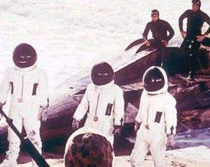

The capsule from Taylor’s ship splashes down off the California coast. Inside are three apes, Zira, Cornelius, and Dr. Milo. They are taken to the Los Angeles Zoo where Milo is killed by a sick gorilla. Zira and Cornelius reveal their ability to speak and become celebrities before they are hunted down by Dr. Otto Hasslein, and killed. Their baby survives and is taken in by Armando, a kindly circus owner. The government dismisses the entire incident as a hoax.

1974

Health food store owner and part-time clarinet player Miles Monroe is accidentally frozen after going to the hospital for an appendectomy. (Sleeper)

1975

Derek Zane, a scientist who believes that Taylor and his crew have been propelled into the future, builds his own time machine with the intent of rescuing the astronauts. He disappears and is never seen again.

1975

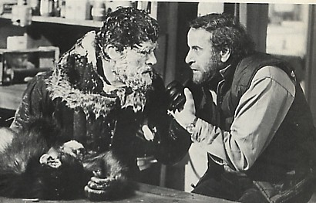

A chimpanzee turns the tables on the two scientists who are studying it by making them the subjects of its own psychological experiment. (The Chill Factor, AKA a Cold Night’s Death)

1976

An abused and misunderstood teenager, Carrie White, displays dangerous telekinetic powers at her high school prom. (Carrie)

1979

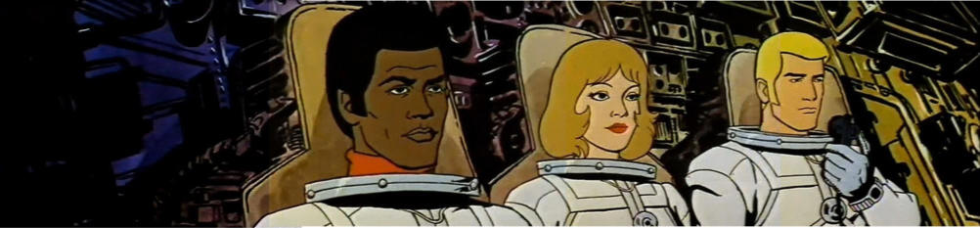

The space capsule Venturer, carrying astronauts Bill Allen, Jeff Hudson, and Judy Franklin is lost in deep space. This is a separate mission, not connected to the ANSA flights.

1979

Scientist Dylan Hunt is put in cryogenic stasis as part of an ongoing attempt to find a way around the problem of deep space flight.

1981

Astronauts Peter Burke and Alan Virdon disappear.

1981-84

Newly elected President Reagan is assassinated by John Hinckley. Vice President Bush takes the oath of office and wins the 1984 election in a landslide. The United States becomes involved in a controversial war in Central America which lasts the rest of the decade. Great advances continue to be made in space travel, computer science, and genetic engineering as space missions are sent out even further and the government experiments with telepathy.

1983

A plague brought back by one of the space missions wipes out cats and dogs, making them nearly extinct. What follows is a period of shock and attempts to replace their lost pets as humans try to readjust. At first they try keeping everything from birds and lizards to pigs, but soon discover that apes are the most intelligent companions. Apes begin to be domesticated and are trained as servants.

1985

A manned mission to Mars carrying astronauts James Norvell, August Burrows, and Ken Flip is lost from tracking scopes. (Adventure Comics, “Countdown Zero”)

1986-89

The Bureau of Ape Management is formed. The status of apes changes from being pets and servants to de facto slavery, although labor unions are successful at keeping ape labor out of the Midwest and East Coast. With the population booming, there is a reverse migration of people from the cities to the countryside. Entire towns become gated communities. Vast areas of farmland are left to go to waste as more crops are genetically engineered in government-subsidized greenhouses. Some areas become heavily polluted, although a massive purification plant in the Rockies keeps the air over the West Coast clean. During this time Cornelius’s son Milo becomes an accomplished performer in Armando’s circus.

1987

Officer Murphy is killed in the line of duty and resurrected in an experimental program, possibly as a response to labor unrest caused by the increasing use of apes in the workforce. He serves the Detroit Police Force for the next several years. His ultimate fate is unknown. (Robocop)

1988

A team of soldiers battle an alien hunter in Central America. (Predator)

1991

The Persian Gulf War. For the first time gorillas are used for security at military installations, and in some cases in actual combat.

1991

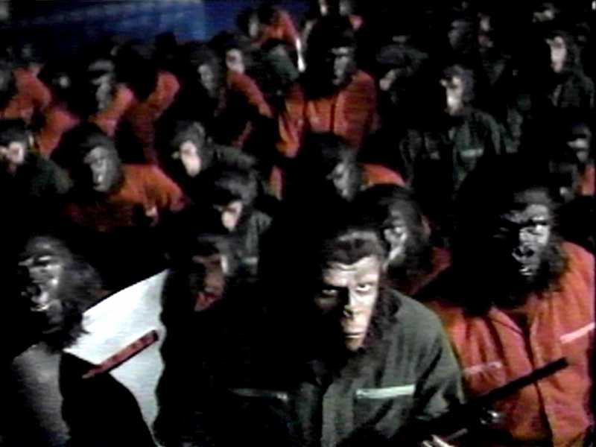

Armando decides that Milo is now old enough to learn the truth about the role of apes in society. After Armando is killed during an interrogation, Milo adopts the name Caesar and leads a rebellion against the Bureau of Ape Management. The revolt is blamed on animal rights activists and dismissed as a hoax. Ironically, this saves Caesar from unwanted attention as he and his followers, including many human sympathizers, go underground.

1995

Both President Clinton and Vice President Gore are assassinated by Gulf War veteran Timothy McVeigh. The Speaker of the House becomes President and declares a state of emergency.

1995

Inspired by Doctor Hasslein’s theories of time travel and believing that one could time travel within his own lifetime, Dr. Sam Beckett steps into a quantum accelerator in Stallion’s Gate, New Mexico, and vanishes. He will spend the next several years leaping from life to life, and will never return home. Stallion’s Gate will eventually become a PAX site.

1996

Partly as a result of Caesar’s rebellion, Los Angeles has become a war zone. Police officer John Spartan is accused of killing several hostages while attempting to apprehend gang leader Simon Phoenix and is placed in suspended animation as punishment. (Demolition Man)

1995-2000

By now, the impact of Caesar’s ongoing rebellion is becoming clearer. The National Police Force is formed to deal with the growing unrest and the Bill of Rights is suspended. The entire island of Manhattan is turned into a prison for malcontents and antigovernment protesters. When the President is kidnapped by revolutionaries, war hero Snake Plisskin is forced to go in and save him. (Escape From New York) Realizing that a conflict between apes and humans may now be inevitable, a group of scientists form the PAX organization to save human knowledge in specific, secret locations. PAX also manages to secretly clone some cats and dogs from DNA that was saved from the Plague. Some of the dogs are genetically engineered with telepathic abilities derived from earlier experiments on humans. The largest corporations are given complete control over the economy and create a violent sport to distract attention away from the spreading ape rebellion. (Rollerball) PAX uses its growing influence with the world’s governments to have a research base built on the Moon, which PAX briefly uses as its main headquarters.

1998

Hoping to stave off impending revolution, European governments grant equality to their apes. For a time apes and humans live as equals under this arrangement. (Adventure Comics, Ape City)

2001

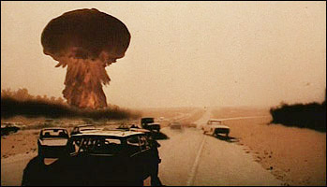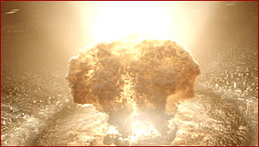

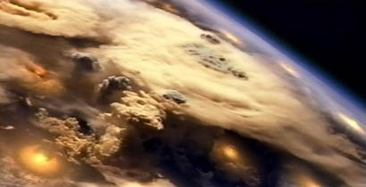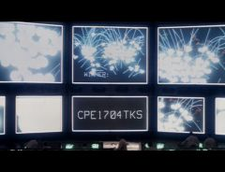

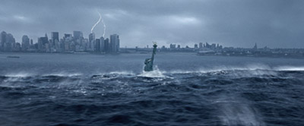

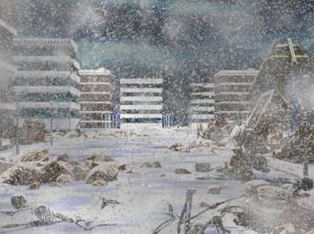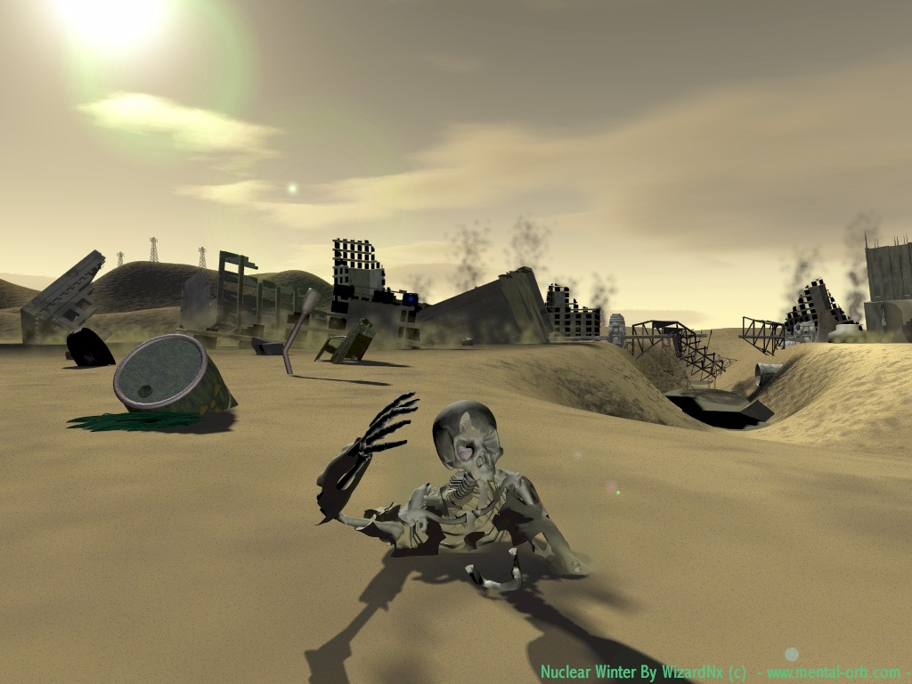

NUCLEAR WAR. Originally believed to be the work of a madman or a mistake, it is actually a desperate attempt to keep the world’s major cities from falling into the hands of the apes. The missiles intended for Washington and New York miss their targets and land in the sea, resulting in a tsunami that floods much of the East Coast, turning it into a wasteland. Caesar and his followers escape from San Francisco and settle in the Santa Barbara area. A group of human survivors, led by Mendez, attempt to survive in the ruins, where they come to view the Alpha-Omega device with an almost religious fervor. PAX abandons the lunar base in order to concentrate on maintaining its still-secret sites.

2003

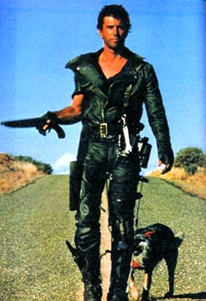

Ex-cop Max Rockatonsky, AKA “Mad Max,” helps a group of survivors defend their fuel depot from a warlord known as the Humongous. (The Road Warrior)

2013

Caesar’s village has become prosperous, but humans are treated as second-class citizens. An insane general named Kolp attacks the new Ape City and is defeated, while Caesar stops a power-mad gorilla and grants equality to the humans. But how long can such a relationship last?

2016

Max helps a group of children who survived a plane crash find their way to a new home after they’re threatened with slavery by the leader of a settlement known as Bartertown. (Mad Max: Beyond Thunderdome)

2017

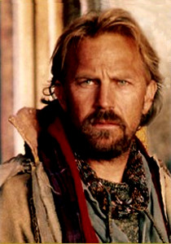

A wanderer discovers a postman’s old uniform and uses it to rally the inhabitants of a small town against a self-styled warlord by getting them to believe in his “Restored United States of America.” (The Postman)

2024

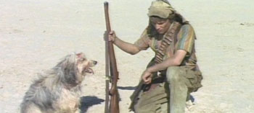

A human teenager named Vic and his telepathic dog, Blood, are captured in an underground society and manage to escape with the help of a girl named Quilla June. (A Boy and His Dog)

2029

Astronaut Leo Davidson disappears into an electrical storm while attempting to retrieve a lost probe that was being piloted by a chimpanzee named Percales. Leo has lived his entire life on the Oberon space station. He and his fellow researchers know only what their superiors at NASA tell them; thus they don’t know about the ape rebellion or the nuclear war.

2032

John Spartan is revived to recapture Simon Phoenix in New San Angeles, which has become an enclave of human culture, the apes having left for Caesar’s Ape City long ago. The city will eventually be abandoned as humans are increasingly targeted by gorilla hunters.

2040

Roger Smith is the chief negotiator for Paradigm City, where everyone lost their memories forty years ago in what is known as “The Great Disaster.” He defends Paradigm with the help of a giant megadeuce, but is it all just a holographic fantasy? (The Big O)

2050

Mendez and his followers leave San Francisco and head for the ruins of New York via a network of underground tube transports. At the same time, unbeknownst to them, Caesar and his followers head for upstate New York, where they found the second Ape City, leaving the first under the leadership of a well-respected orangutan.

2067

Caesar dies. Control of Ape City is given to a highly respected orangutan who becomes the First Lawgiver.

2070

Jason and Alexander, an ape and a human who were raised together, join the first Lawgiver in stopping a power-mad gorilla from taking control of the new Ape City.

2100

A fleet of ships is launched by PAX to colonize another planet in the hope of keeping the human race alive. On one of them, two genetically engineered brothers, Vash and Knives, grow up together under the loving care of Rev Bem. Knives sabotages the fleet, however, forcing the ships to crash-land prematurely on the new planet, which is named Gunsmoke. Decades later, Vash is known as Vash the Stampede, the Humanoid Typhoon with a 60 million double-dollar bounty on his head for the destruction of a settlement called July City. He is watched over by Meryl Strife and Millie Thompson of the Bernadelli Insurance Society in order to keep him from causing any more damage-which is usually caused by those after him for the bounty. After several adventures, Vash has a final confrontation with his evil brother and disappears. (Trigun)

2109

Ron Brent, a descendent of the original, is launched into space. He enters a familiar time warp and disappears.

2113

Caesar’s grandson, Alexander, is struggling with the burdens of leadership in Ape City, while in Europe; the apes have taken over completely in France, where the humans were killed by a plague. They are enjoying the technology left behind by the humans when they are threatened by a group of humans from the past led by Col. Taylor’s daughter who call themselves The Vindicators. (Adventure Comics, Ape City)

2125

Four astronauts-Ulysses, Romulus, Sophie, and Martinez-are launched into deep space on their ship, the Cassiopeia.

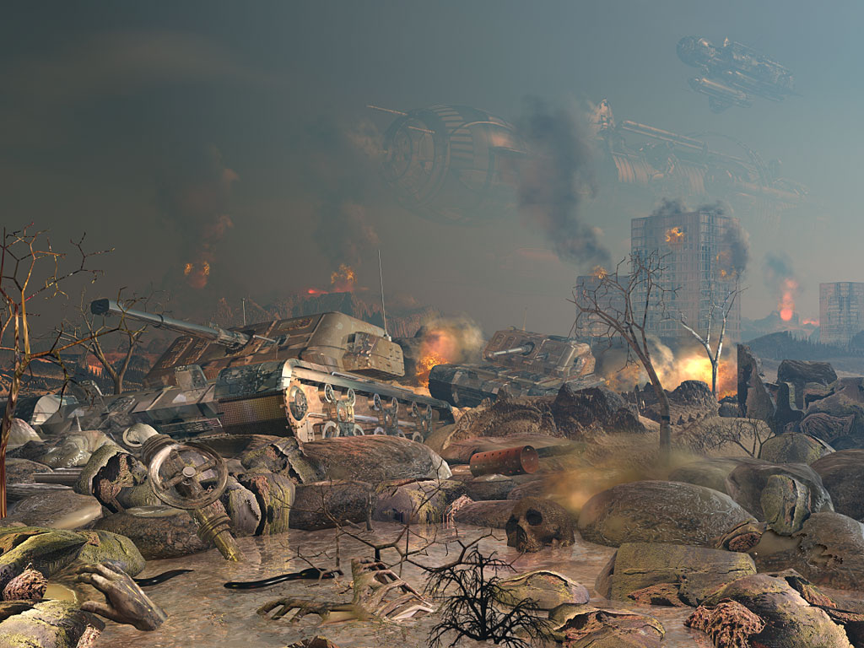
Figure 1The Human/Ape War Continues, circa 2150 A.D.

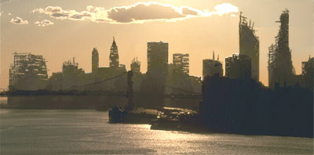
Figure 2 The ruins of Manhattan

2173

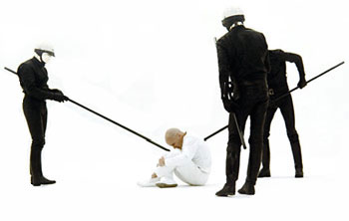

A human known only as THX-1138 escapes from an oppressive underground society.

2220

Two huge ape and human armies battle each other forty miles from San Francisco. A gorilla, Solomon, and a human, Jovan, are the only survivors and form an uneasy but necessary truce. They are taken in by the human/ape mutant Mordecai and taught by him, until they meet their deaths at the hands of human/ape mutants in San Francisco.

2233

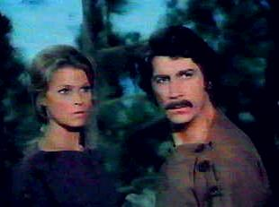

Dylan Hunt is thawed out of stasis and helps prevent a female dictator from destroying PAX headquarters. (Genesis II)

2273

Miles Monroe is thawed out by renegade scientists living in the North American Federation, which was originally one of the human enclaves created by PAX but which has since become a dictatorship. He helps to prevent the Federation from cloning their Great Leader with the help of Luna Schlosser, a young woman whom he inadvertently takes captive.

2274

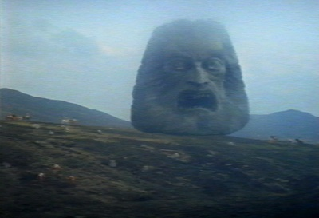

Zed, an Enforcer for a cult centered on a giant floating head, helps bring down a decadent civilization by introducing death into their sheltered world. (Zardoz)

2300-2500

With the loss of their technology, the Europeans regress to a medieval state of existence. Fearing renewed enslavement, the apes immigrate to North America, where they are assimilated into the various Ape Cities.

2476

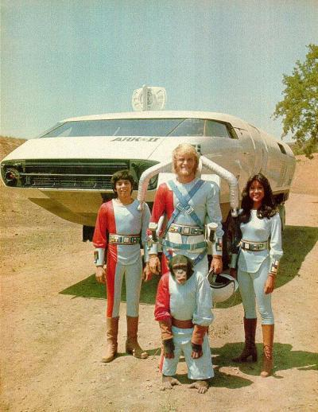

A trio of PAX scientists and their chimpanzee companion travel across the Southwest in a high-tech vehicle in an attempt to bring back lost knowledge of the past. (Ark II)

2575

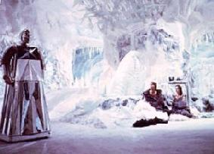

Logan Five and Jessica Six escape from the City of Domes, where no one is allowed to live past thirty. They come back after discovering the ruins of Washington DC and free the City’s people from the oppressive rule of the city’s Master Computer. (Logan’s Run)

2700

After Leo Davidson’s disappearance, the Oberon follows him into the electrical storm. It crash-lands in the Forbidden Zone, where an ape named Semos takes control, forcing the humans into slavery. He attempts to warn the other apes that Percales will return someday to free the humans, but this is misread as the second coming of an Ape Christ. They build their own Ape City in the Forbidden Zone.

2750

A particularly daring raid by humans into a fairly large ape population leads to a widespread public outcry from the apes. Systematic destruction of the outlaw bands is instituted. The Lawgiver of the day rewrites the Sacred Scrolls to give an unflattering portrayal of humans.

3085

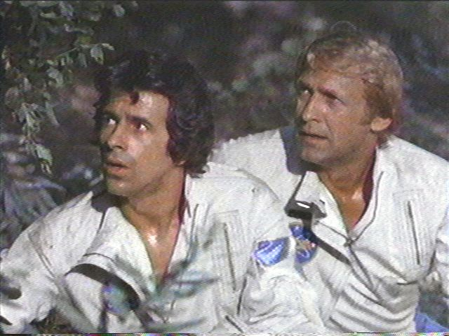

Pete and Alan land outside the first ape city, where they are captured. They find that humans are now slaves, and manage to escape with the help of Galen, a friendly chimpanzee. They will remain on the run for the next several years, until Alan finally finds a way home with the help of an astronaut from their own time. (Mike McColm, Fan Comic “Return To Yesterday,” available at www.planetoftheapestv.150m.com)

3100-3500

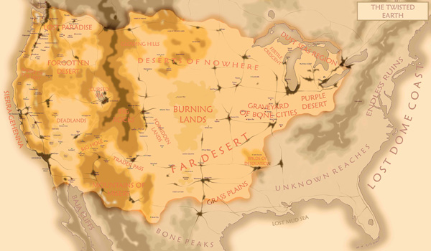
Figure 3 North America Circa 3500 A.D.

Pete and Alan’s arrival is the event that triggers the final separation between humans and apes. Some humans with draw from ape society completely and become nomads, while others are hunted down for sport and used in medical experiments. It is a time of cultural stagnation in North America as ape society comes under the control of conservative orangutans who institute a rigid class structure with them at the top, chimpanzees in the middle, gorillas in the third tier, and humans at the bottom. The mysterious human/ape hybrids die out, and the West Coast is almost entirely abandoned. Overpopulation forces the inhabitants of the underground cities to abandon them for the surface, where most of them are hunted down by Gorillas. The remaining survivors find a safe haven in the Northwestern Federation, which by now has become the only remaining stronghold of human culture left in North America outside of New York City.

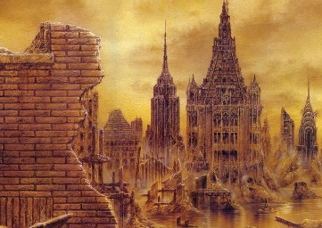
Figure 4 The Forbidden Zone, Circa 3600 A.D.

3700

Leo lands on the edge of the Forbidden Zone. He is soon captured as all the others were and sold into slavery in the Ape City. He is befriended by Ari, a sympathetic human rights activist, who helps him escape to ancient ruins which turn out to be those of the Oberon. Leo helps the humans free themselves from slavery and attempts to return to his own time, but instead winds up an Earth run by apes…which turns out to be a hallucination, brought on by stress and exhaustion. Leo is actually being hurtled back through time…

3889

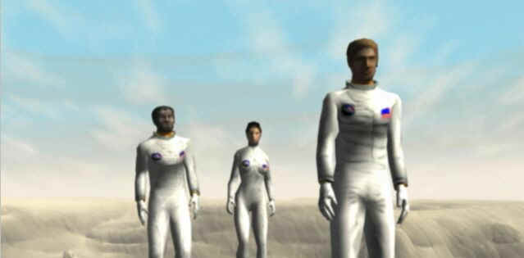

The Cassiopeia returns to Earth. After Martinez is found dead, Ulysses and his two surviving companions explore the Forbidden Zone, where Sophie and Romulus are killed in a hunt. Ulysses is taken to Ape City for medical experiments. He manages to escape and tries to find the long-missing Taylor, not realizing that he has landed nearly a hundred years too early. His fate remains unknown. (Planet of the Apes computer game)

3978

Taylor and his crew land in the Forbidden Zone. Stewart is discovered to have died while in suspended animation; Dodge is killed in a hunt, while Taylor is shot in the throat and taken to Ape City. His intelligence capture’s Zira’s attention. When he regains his ability to speak, Taylor is put on trial as a freak of nature. He escapes into the Forbidden Zone with Nova, a human female, where he discovers the shocking truth of where he is.

Ron Brent Senior’s ship crashes in the Forbidden Zone. He is the only survivor of his crew and encounters Nova after burying his Skipper. They make their way to Ape City in search of Taylor and run into Zira and Cornelius, who help them escape. They are followed by a gorilla army led by a reluctant Dr. Zaius. Brent and Nova discover an underground passage which leads them to the ruins of New York City, where they are captured by telepathic mutants who worship the Alpha-Omega device. Brent is reunited with Taylor, but is killed by gorillas while trying to help him defuse the device. Bleeding profusely from a shoulder wound, a delirious Taylor drops his hand over the Alpha-Omega Device’s control rods and pushes one of them down. There is a blinding flash of light and at first all seems lost…

What they don’t know is that the device was actually disarmed centuries earlier by Caesar, who wanted to prevent history from repeating itself. The rocket launches, triggering an earthquake that causes the overhead rocks to cave in, killing most of the gorilla army. Believing Taylor to be dead, Zaius and his remaining forces leave New York City, which has become exposed to the surface for the first time in centuries. Nova, who was shot in the back and not killed as originally believed, but only wounded, finds the badly wounded Taylor and helps him out of the rubble. Together, they head for parts unknown. Taylor has become mentally overwhelmed and wanders off, leaving Nova alone once more.

3979

In Ape City, the chimpanzees, inspired by Zira, have staged a successful revolt and the orangutans are forced to agree to reforms. Their desire for power makes the apes advance rapidly and they soon have automobiles, televisions, and newspapers. Within a year, they have rebuilt much of New York City, while the old Ape City becomes a ghost town.

Jeff, Judy, and Bill land in the Forbidden Zone, where they meet Nova. Judy disappears into a chasm. Jeff and Bill are captured in another hunt and taken to the new Ape City, where their intelligence raises eyebrows. Zira and Cornelius help them escape before restoring Taylor’s spaceship and making their own journey back into the past. In space, they see an electrical storm which they misinterpret as the end of the world. When Zaius returns, he finds an Ape City that has been greatly changed in his absence and is forced to accept the changes that have taken place. He learns of Zira and Cornelius’s disappearance and realizes that the circle has become complete. The question now becomes what happens to ape civilization, and the humans?

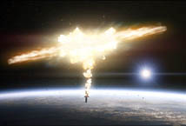
Figure 5 the Alpha-Omega Device Exploding In Earth Orbit

3980

Jeff and Bill are reunited with Judy, and encounter Ron Brent Junior, who has been living the life of a hermit in a place called Hidden Valley. They learn that Nova’s tribe discovered him when he first landed and that he helped fix her broken leg when she was a child. He decides to remain behind while they press onward in search of Taylor.

3981

The quartet finally finds Taylor, who has regained his sanity. Nova is happy to be reunited with him. He understandably has no interest in going back to New York City and so never gets to see what the apes have done with it. Instead, they head south, where they discover the ruins of Washington, DC and learn more about the history of the ape rebellion from ancient documents and videotapes. They also learn that Cape Canaveral is now a PAX site, and head there, hoping to find a way back to their own time.

Meanwhile, Leo manages to return to the space station in his own time. After convincing the others of what happened to him by making them contact earth to confirm the existence of the Ape rebellion, the station’s captain decides to take the station back to earth in an attempt to help stop the rebellion from spreading any further than it already has, and to help Earth recover from the nuclear war. Instead, they fall through the electrical storm, and crash-land not far from the NASA PAX site. After giving thanks for being alive, the captain organizes an expedition to the PAX site after receiving TV and radio transmissions from Ape City and realizing that they can’t go there.

Taylor’s group gets there first. They find that life at NASA is much like it was in the 1960’s, with the exception that travel outside of the base is forbidden, although no one there knows why except for a few elites. Taylor manages to secure a meeting with NASA’s leaders and gets sanctuary for him and the others. After monitoring news broadcasts from Ape City, they learn that General Ursus is planning to invade, having discovered the existence of PAX sites from records that were kept secret by the orangutans when they were still in power. At about this time, Leo and his group arrive. Although they are initially viewed with suspicion by NASA’s leaders, Taylor believes they should work together to stop Ursus’ invasion. At the same time, NASA scientists work around the clock in a race against time to build a spaceship capable of carrying all of them back into the past, hoping to finish it before Ursus arrives. They don’t quite make it, and Taylor and Leo lead NASA’s inhabitants in a last stand against Ursus’ superior numbers. Just when it looks as if they are about to lose, the cavalry arrives in the form of Dr. Zaius, who has finally had enough of Ursus’ aggression, along with a force of loyal gorillas and chimpanzees. Ursus is killed in a final battle with Taylor. Zaius agrees to allow him and the others to leave, and promises to try and find a way for humans and apes to live together. He has seen the error of his ways and grudgingly admits that Taylor was right-humans were there first, and the apes owe them their culture. He also tells Taylor about Zira and Cornelius’s departure and just how much he really knows about his world’s history. Taylor nods; the Planet of the Apes finally makes sense to him now. He sadly agrees that under the circumstances, history couldn’t have happened any differently-but maybe he can change that once he returns to the past. Zaius wonders what his own time might be like if Taylor succeeds and if he or the ape civilization will even still exist. Taylor replies that intelligent apes and humans working together might do a better job than either one of them did separately, leaving Zaius with something to ponder. Taylor and the others board the newly finished spacecraft while the rest of Leo’s companions from the Oberon decide to remain behind to try and help the apes and humans find common ground. The ship lifts off, heads into the electrical storm, and travels back in time to…

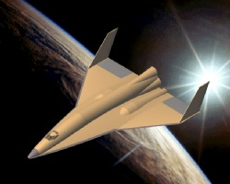
Figure 6 Taylor And His Companions Returning To the 20th Century

1961

They land in the Pacific Ocean and are rescued by the U.S. Navy. After convincing the Navy that they aren’t Russian spies, they get a secret meeting with President Kennedy. Kennedy agrees to scrap the ANSA project, thus changing history and creating what is now our timeline. As a result, Taylor does not go on his original mission, and Zira and Cornelius do not use his spaceship to go back in time. Unknown to them at the time, their arrival creates a ripple effect in time which causes a jet airliner to be sent back in time, a World War One pilot to land at a modern U.S. Air Force base in France, a settler leading a wagon train to temporarily find himself at a contemporary gas station, and a professor to find himself sent back in time to the night that Abraham Lincoln was shot. (The Twilight Zone, “The Odyssey of Flight 33,” “The Last Flight,” “One Hundred Yards over the Rim,” and “Back There.”)

Taylor and Nova are still alive today and have many children and grandchildren. They have been living under different names, as have the others. In 1964, Taylor told his story to Rod Serling, who realized the need to tell it as fiction, and thus was born the Planet of the Apes saga. Leo stayed with NASA and helped design both Skylab and the International Space Station. Bill, Jeff and Judy all live quiet lives. There was no Plague in our timeline, no ape rebellion, and no nuclear war. History has been changed. For now…

